Personal Comments about the website on 1 Dec 2023

Responsiveness – Satisfactory 6 out of 10. It's just that it looks too long, ie. You have to scroll for so long before you get to the footer.

General Website Comment – Some areas look obsolete. It doesn’t really communicate.   
The whole website does not really sell us out. The home page should tell more about the various schemes or offers that we provide.  
  
Homepage 4.5 out of 10, but overall website can be rated 6.5/10

**Suggested Improvements**  
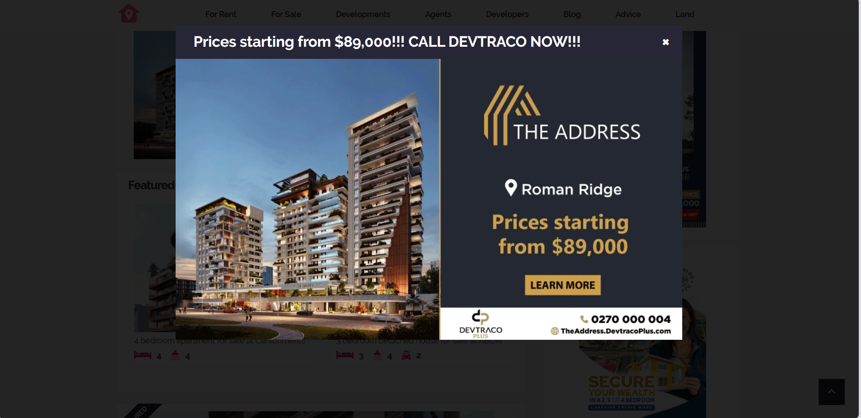

There should be modal like this that will be termed, **deal of the day =** *it may even be dedicated to selling houses or properties of others*.

***QUESTIONS TO GET THE BEST OUT OF OUR TASK***

**FRONT-END SPECIFIC**

Are the options on the nav bar cool??

**COMPANY-SPECIFIC QUESTIONS**

How is the company like?  
How do they operate?

* Have lands and buildings
* Sell lands and buildings for others

How do we get data about the lands and houses to initially populate our db?

pictures

videos

google maps location